Warehouse Management – TRA2230
ELLUMINATE SESSION #1
WEEK 1

- Have class briefly introduction themselves.
- Review the Supply Chain and Distribution flow charts to introduce the course.
Supply Chain Flow Chart
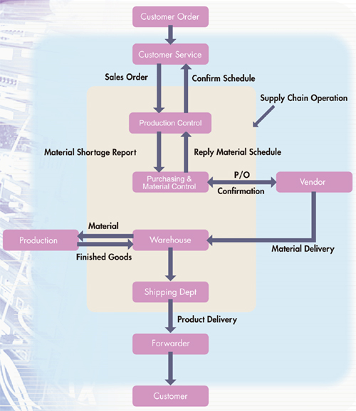
Distribution Flow Chart
